CSE370 : Database Systems
Assignment 01/02/03 | Spring 2026
ID : 23241004 | Name : Afnan Mohammad Hafiz

No 1 Query  (as Plain Text) | select c.customer_name, l.loan_number  from customer c  join borrower b on c.customer_id=b.customer_id  join loan l on b.loan_number=l.loan_number  where l.branch_name = 'Downtown';
No 1 SS  (of Query & Output  in Shell) | 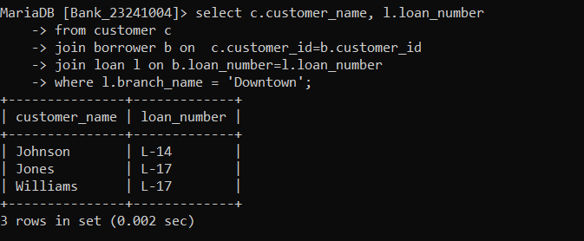
No 2 Query  (as Plain Text) | select distinct c.customer_name  from customer c  join borrower b ON c.customer_id=b.customer_id;
No 2 SS  (of Query & Output  in Shell) | 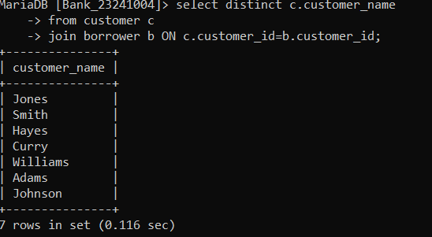
No 3 Query  (as Plain Text) | select c.customer_name  from customer c  left join borrower b on c.customer_id = b.customer_id  where b.loan_number is null;
No 3 SS  (of Query & Output  in Shell) | 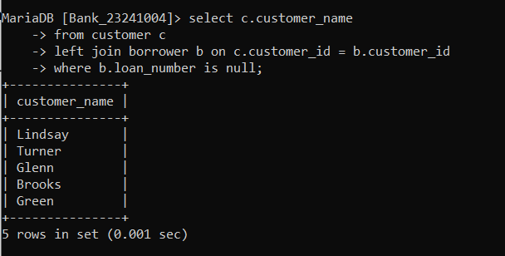
No 4 Query  (as Plain Text) | select c1.customer_name as Customer1, c2.customer_name as Customer2, c1.customer_city as City  from customer c1  join customer c2  on c1.customer_city=c2.customer_city  and c1.customer_id < c2.customer_id;
No 4 SS  (of Query & Output  in Shell) | 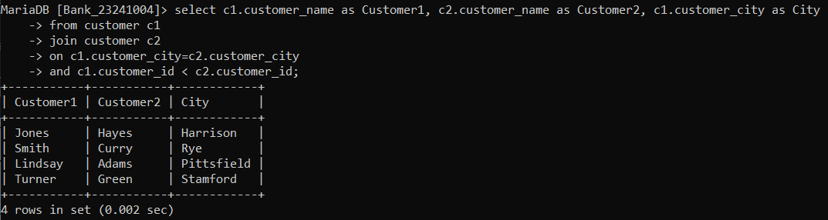
No 5 Query  (as Plain Text) | select branch_name,  round(sum(balance * 0.04), 2) as Total_Interest  from account  group by branch_name;
No 5 SS  (of Query & Output  in Shell) | 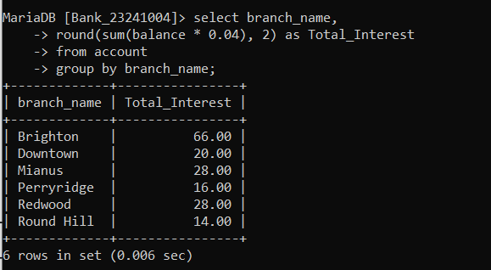
No 6 Query  (as Plain Text) | select c.customer_city, a.account_number, a.balance  from account a  inner join depositor d on d.account_number = a.account_number  inner join customer c on c.customer_id = d.customer_id  where a.balance =(  select max(a2.balance)  from account a2  inner join depositor d2 on d2.account_number = a2.account_number  inner join customer c2 on c2.customer_id = d2.customer_id  where c2.customer_city = c.customer_city  );
No 6 SS  (of Query & Output  in Shell) | 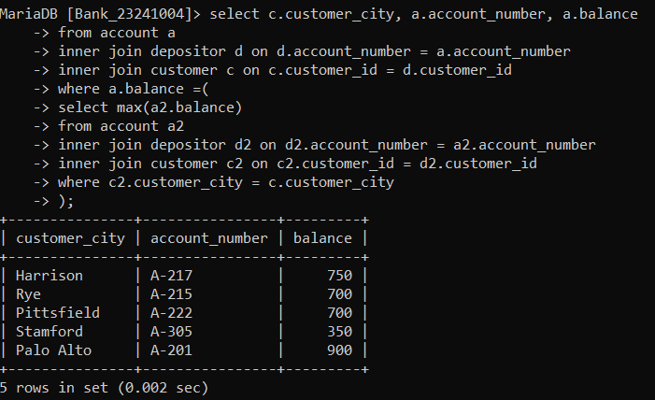
No 7 Query  (as Plain Text) | select l.loan_number, l.amount, c.customer_name  from loan l  inner join borrower b on l.loan_number=b.loan_number  inner join customer c on b.customer_id=c.customer_id  order by l.amount desc, l.loan_number desc  limit 5;
No 7 SS  (of Query & Output  in Shell) | 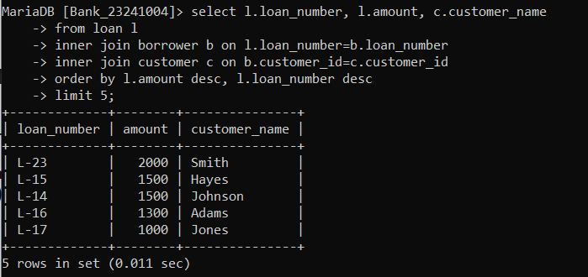
No 8 Query  (as Plain Text) | select distinct c.customer_name  from customer c  inner join depositor d on c.customer_id=d.customer_id  inner join account a on d.account_number=a.account_number  inner join borrower b on c.customer_id=b.customer_id  inner join loan l on b.loan_number=l.loan_number  where a.branch_name='Perryridge'  and l.branch_name='Perryridge';
No 8 SS  (of Query & Output  in Shell) | 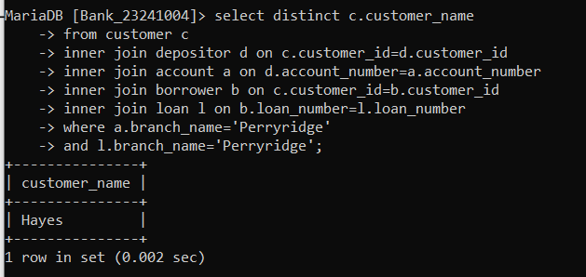
No 9 Query  (as Plain Text) | select c.customer_name, sum(l.amount) as total_loan  from customer c  inner join borrower b on c.customer_id=b.customer_id  inner join loan l on b.loan_number=l.loan_number  group by c.customer_name  having count(l.loan_number)>=2;
No 9 SS  (of Query & Output  in Shell) | 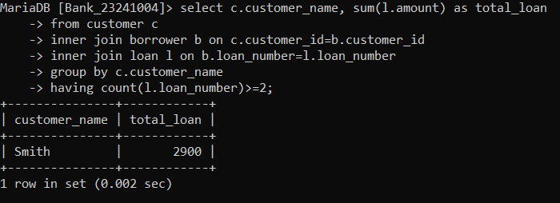
No 10 Query  (as Plain Text) | select d.customer_id, sum(a.balance) as total_balance  from depositor d  inner join account a on d.account_number=a.account_number  group by d.customer_id  having count(d.account_number)>1;
No 10 SS  (of Query & Output  in Shell) | 